The Gap between Video Games and Hardware Smart Trainers

Video games are electronic applications that let users interact with a user interface that generates visual feedback. User input is provided through some hardware input device, commonly a gaming controller, mouse and keyboard, or directly through a touch screen, depending on the kind of gaming platform. Common platforms are gaming consoles, like Xbox and PlayStation, personal computers, and mobile devices.

In commercial gyms, smart trainers (STs) that provide visual feedback and other forms of gamification are becoming a more and more common sight. A concept related to the gamification of STs is exergaming, which is a “new genre of videogames that are geared towards promoting physical acivity” [Sween J, Wallington SF, Sheppard V, Taylor T, Llanos AA, Adams-Campbell LL. The role of exergaming in improving physical activity: a review. J Phys Act Health. 2014 May;11(4):864-70. doi: 10.1123/jpah.2011-0425. PMID: 25078529; PMCID: PMC4180490.]. It has also been defined as “digital games that require bodily movements to play, stimulating an active gaming experience to function as a form of physical activity” [Benzing V, Schmidt M. Exergaming for Children and Adolescents: Strengths, Weaknesses, Opportunities and Threats. J Clin Med. 2018 Nov 8;7(11):422. doi: 10.3390/jcm7110422. PMID: 30413016; PMCID: PMC6262613]. Also, communities emerge, who compete in indoor cycling from the comfort of their home, using applications like Zwift. Zwift claims to have had up to almost 50 thousand concurrent users during peak hours according to data published by the company in 2022 [<https://zwiftinsider.com/zwift-stats/>].

## User Account of Zwift from Lars

Below is a diagram that shows data from a completed training based on the plan the app provided for the session.

The tool divides the training session into six-time intervals where it begins with a one for warmup and then gets more intensive training. Interesting is that the application provides recovery recommendation in terms of a number of recovery days, based on the amount of work the bicycle rider completes, measured in number of intervals and their average watts.

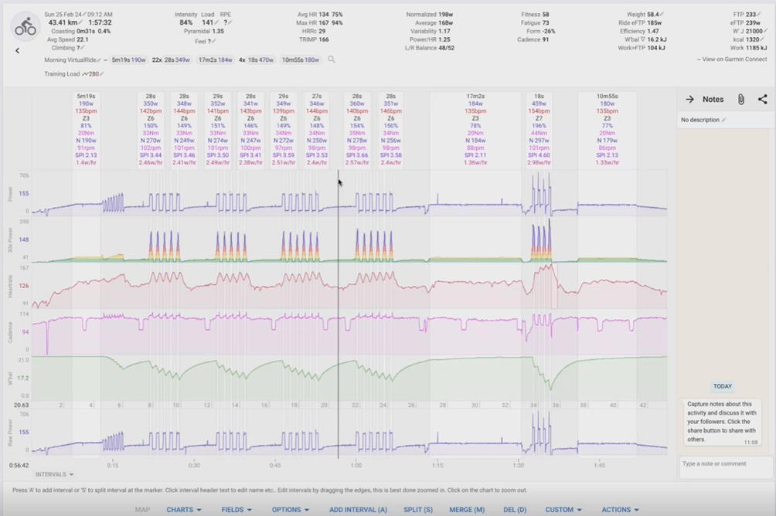

In addition to providing intelligent recovery recommendations, Zwift also controls the resistance for the rider, to provide a form of dynamic adaptation of the resistance during a workout. This is an example of the two-way communication that is possible with existing STs.

Another gamifying aspect of Zwift is that it provides graphs for the user to analyse their workouts, which is a form of creating transparency for the user.

The communication between the Zwift app and the smart trainer happens through either bluetooth (BT) or ANT+ protocol.

Lars prefers the ANT+ connection because he experienced it as being a more stable stream of communication. He does not prefer BT because he experienced losing connection multiple times.

## Physiological and Psychologic al Benefits of Gamification for Fitness

It has been established that “gamification can have a positive impact for health and wellbeing related interventions”, specifically targeting “behavioural outcomes, particularly physical activity”. [https://www.sciencedirect.com/science/article/pii/S2214782916300380].

## The Role of the Gaming Industry in Gamifying Fitness Equipment

Gaming publishers like Rockstar have the potential to play a pivotal role in bridging the gap between traditional video gaming and fitness equipment. By leveraging their expertise in engaging storytelling and immersive game design, these publishers can create compelling fitness-oriented games that encourage physical activity. The gamification of fitness equipment, when guided by top-tier game developers, can transform mundane exercise routines into exciting and rewarding gaming experiences. This not only boosts user motivation but can also attract a wider audience to gyms and home workout setups, making fitness more accessible and enjoyable for everyone. Through partnerships with fitness technology companies, gaming publishers like Rockstar could drive innovation in exergaming, enhancing the interactivity and functionality of STs.

Developers of gaming controllers and hardware devices also play a crucial role in the gamification of fitness equipment. By designing controllers that are versatile and adaptable to various forms of physical activity, these developers can enable more dynamic interactions with fitness games. For instance, motion sensors, wearable technology, and haptic feedback systems can be incorporated into traditional fitness equipment to capture a wider range of user movements and provide real-time performance feedback. This technology enhances the user's engagement by making the physical activity feel more like playing a video game, which can significantly improve the user experience. The innovation from these hardware developers not only supports more effective and immersive exergaming environments but also encourages continuous technological advancements in how fitness and gaming intersect.

This project explores the feasibility and potential methodologies for integrating data streams from commercial gym STs as input mechanisms within video games.

# Differring Technologies of STs and Gaming Products

One obvious fundamental challenge for integrating gym equipment into video games is that the usual output provided by these devices does not encompass the advanced functionality of standard input devices for video games. In other words, STs are not meant to be used as controllers for video games.

## Technologies used for Gamifying STs

There are multiple ways the fitness industry already gamifies STs. One possibility is simple video streaming, usually of some natural landscapes, or similar.

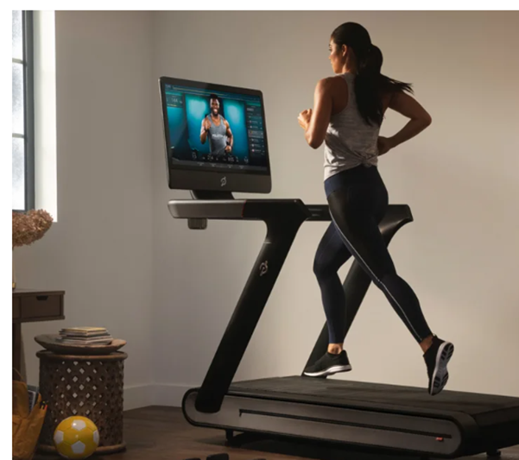

Another possibility is that STs provide a display the user can get feedback from to their actual movements on the trainer. In this case, the screen serves as a personal coach that guides the person to go harder or to slow down the movement based on a concrete training plan.

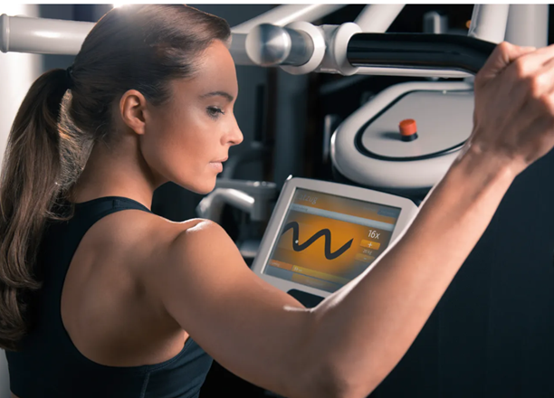

## VR Locomotion

Gaming products are already being used with more input dimensions from the human body than with traditional controllers. Virtual reality locomotion (VR locomotion) are techniques to allow a user to interact with video games with additional dimensions of their motion, than just using the hands with standard input devices. VR locomotion devices are specifically designed to allow for these additional dimensions of input. The devices are still expensive to access for most users, leading to an industry of VR gaming places, where users can buy a day pass or other paid time-restricted access. Also, the devices are usually not meant for fitness training, and might not provide the same durability and maintainability that is required for commercial gyms fitness equipment. Integrating VR locomotion with fitness equipment could enable exergaming on a larger scale, lowering the entry barrier for gym owners to gamify their users experience.

## Communication Protocols between the fitness machine and the devices:

The protocol used for connecting screens to gym machines can vary depending on the specific technology and connection method employed. Here's a breakdown of the protocols commonly associated with each connection method:

1. **Built-in screens**:

- When the screen is built directly into the gym machine's console, the protocol used for communication between the screen and the machine's internal electronics may not necessarily be standardized or exposed to the user. The manufacturer typically implements proprietary communication protocols optimized for their specific hardware and software integration.

2. **External monitors**:

- If the gym machine supports connecting external monitors or devices, it may utilize standard protocols such as:

- HDMI (High-Definition Multimedia Interface): HDMI is a widely used protocol for transmitting high-definition audio and video signals between devices. Gym machines with HDMI ports can output video signals to compatible external displays.

- DisplayPort: Similar to HDMI, DisplayPort is another standard for transmitting audio and video signals. Some gym machines may feature DisplayPort output ports for connecting external monitors.

- VGA (Video Graphics Array): While less common in modern equipment, some older gym machines may support VGA output for connecting to analog monitors.

3. **Wireless connectivity**:

- For wireless connectivity options such as Bluetooth or Wi-Fi, gym machines typically implement industry-standard protocols for communication with compatible devices:

- Bluetooth: Bluetooth Low Energy (BLE) is commonly used for connecting smartphones, tablets, smartwatches, and other wearable devices to gym machines. The Bluetooth protocol enables wireless data exchange and control between the machine and the connected device.

- Wi-Fi: Gym machines equipped with Wi-Fi connectivity can connect to local networks or the internet. They may use standard Wi-Fi protocols such as IEEE 802.11ac or 802.11ax for wireless communication.

4. **Network connectivity**:

- Gym machines with network connectivity options typically utilize standard network protocols for communication:

- TCP/IP (Transmission Control Protocol/Internet Protocol): TCP/IP is the foundational protocol suite used for communication over the internet and local networks. Gym machines with network connectivity use TCP/IP for data exchange, accessing online content, and software updates.

- HTTP/HTTPS (Hypertext Transfer Protocol/Secure): HTTP and HTTPS are application-layer protocols used for transmitting hypertext documents, often associated with web browsing. Gym machines may use these protocols for accessing web-based content and services.

- Other application-specific protocols: Depending on the features offered by the gym machine (e.g., streaming services, virtual training platforms), additional application-layer protocols may be employed for specific functionalities.

These are some of the common protocols associated with each connection method for screens on gym machines. Specific implementations may vary based on the manufacturer and model of the equipment.

To sum up. It can be considered that the gamification elements help to increase the

## Integrating Existing Fitness Equipment and Video Games

The difference between the output of standard video game input devices and fitness equipment, on a conceptual plane, is that the output stream of standard video game input devices has more dimensions than the output stream of standard fitness equipment. E.g., the output of a game controller can contain the simultaneous output of multiple joysticks and buttons, while fitness equipment usually only provides a single metric that is be relevant for VR locomotion, i.e., the user’s raw energy output.

A software solution could potentially converge the data streams of gaming controllers and fitness equipment to enable existing fitness equipment to be used as input for existing video games. Integrating existing technology from both domains could potentially be a *proof of concept* for the possibility of innotvation in exergaming, enhancing the interactivity and functionality of STs.